CHAPTER 8: The dynamic Earth
© Austral International/Rex Features
Worksheet 8.3

Folding and faulting
Student: Class:

The San Andreas Fault
1. The following diagram and photograph shows the San Andreas Fault in California.

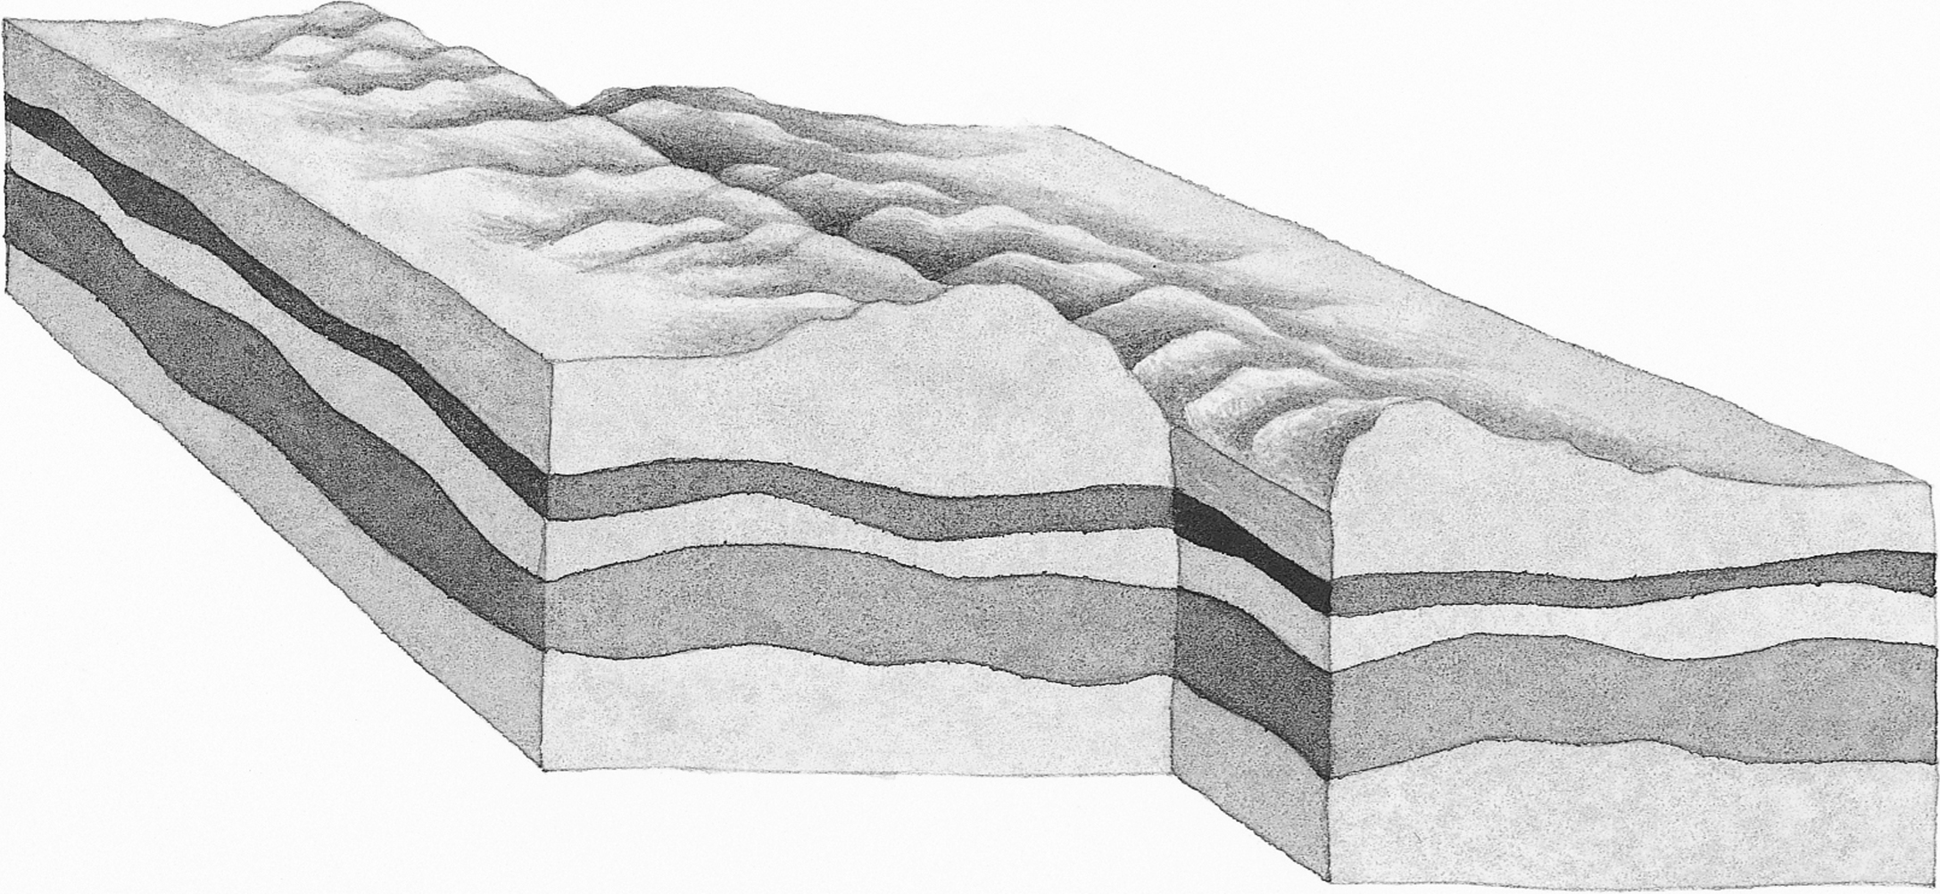

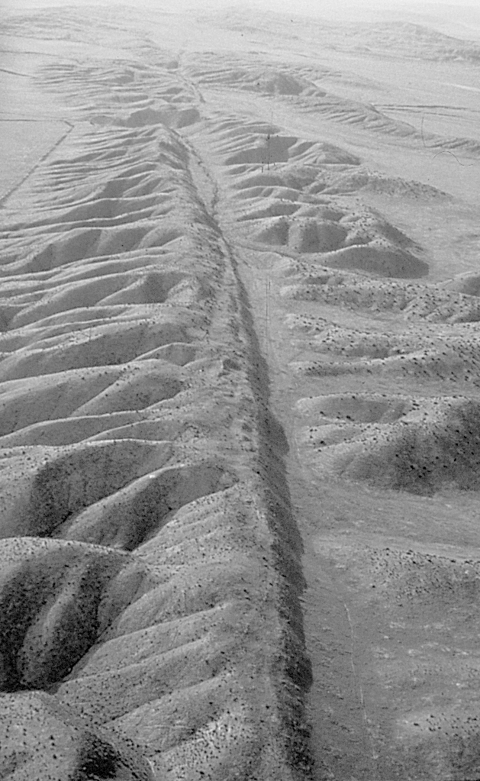 | (a) Identify this type of fault.  (b) On the diagram above use arrows to show the direction of the plate movement on either side of the fault line.  (c) What is produced when movement occurs along this fault line? …………………………………………...

CHAPTER 8: The dynamic Earth
Worksheet 8.3

Page 2

Bending rocks
2. When rocks are squeezed deep in the Earth they may soften and bend rather than break.
Look at the supplied diagram below.
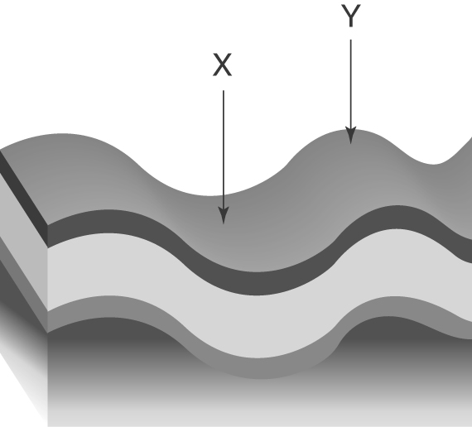 | (a) Identify the folds labelled X and Y.  © Sujin Jetkasettakorn/123RF  X:  Y:
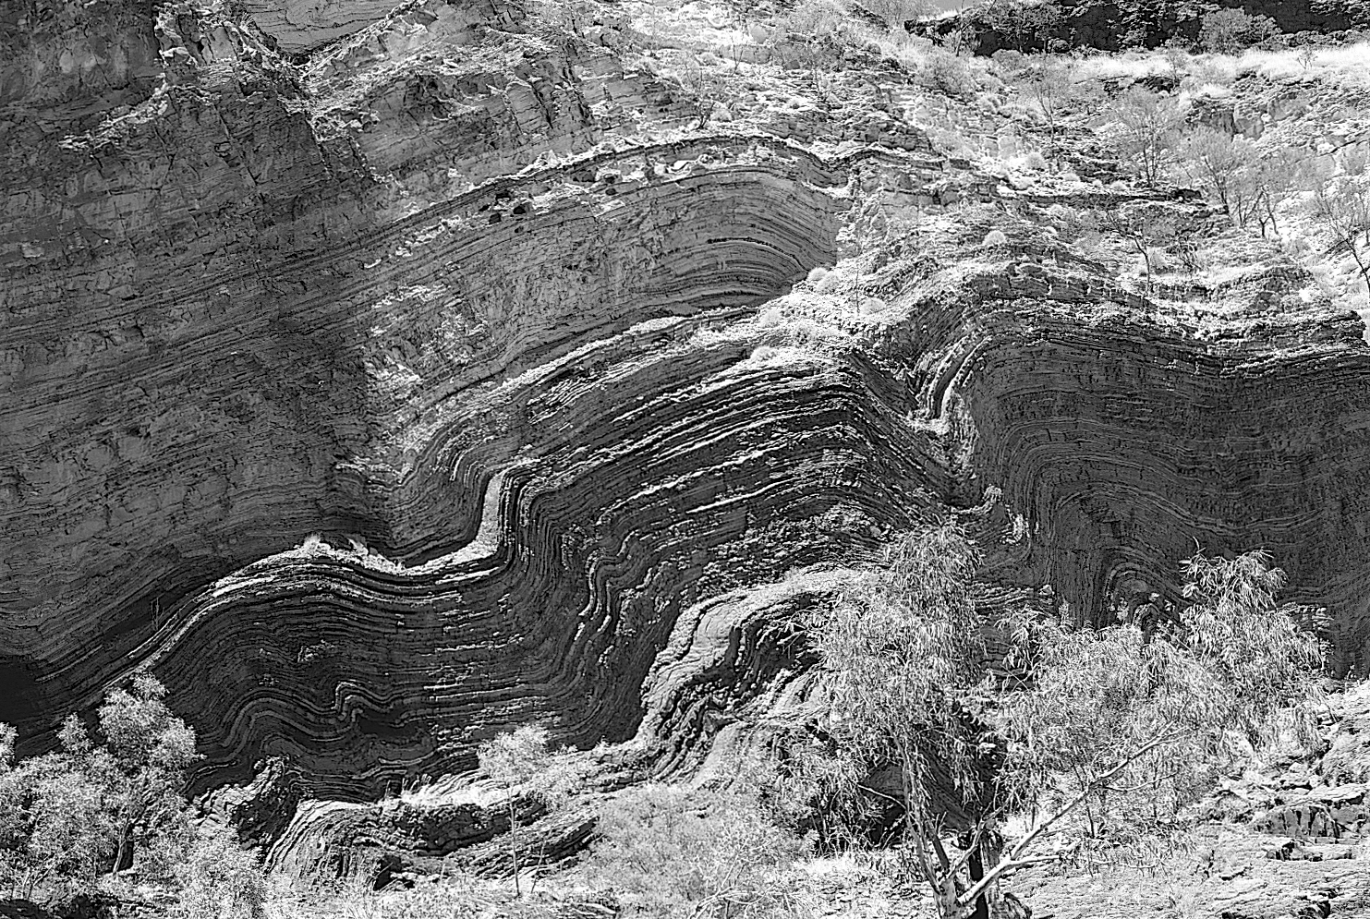 |  | (b) The photo shows a section of rocks in the Hamersley range in Western Australia. Explain how these formations were produced.

Normal and reverse faults
3. Draw and label 2D diagrams to distinguish between a normal and a reverse fault. Show the direction of rock movement along each fault.
Normal fault | Reverse fault

